

|  |  |
| --- | --- |
| **Name:** | **Muhammad Muqeet Bhatti**  **Muhammad Imran Khan**  **Azib Hassan**  **Sheraz Ul Hassan** |
| **Registration Number:** | **L1F23MBAM0058**  **L1F23MBAM0086**  **L1F23MBAM0084**  **L1F23MBAM0098** |
| **Date** | **Jul 02, 2024** |
| **Instructor** | **Sir Nouman Yaqoob** |

**Analysis Report on Amazon's Sales Data**

**Introduction**

This detailed analysis report provides comprehensive insights into Amazon's sales data from 2010 to 2017. The analysis delves into various aspects such as revenue generation, profit margins, sales trends, and regional performance. The data, sourced from Kaggle, has been thoroughly examined to derive actionable business strategies for Amazon.

**Company Overview**

Founded by Jeff Bezos in 1994, Amazon is a global leader in e-commerce, cloud computing, digital streaming, and artificial intelligence. Known for its innovative approach and customer-centric focus, Amazon continuously expands its services, including Amazon Web Services (AWS), Prime Video, and Alexa.

**Data Overview**

The dataset spans seven years of sales data, covering a wide range of product categories and regional sales information. This comprehensive dataset allows for a detailed analysis of Amazon's performance across various dimensions.

**Key Findings**

**Revenue Analysis**

The revenue analysis reveals that cosmetics generated the highest revenue, amounting to $36.6 million, which accounts for 26.65% of the total revenue. This category's strong performance indicates high consumer demand and effective sales strategies. Office supplies followed, generating $30.59 million and contributing 22.27% of the total revenue.

This consistent performance highlights the importance of office supplies in Amazon's product portfolio. On the other hand, fruits generated the least revenue at $466.4k, making up just 0.34% of the total revenue, suggesting a need for strategic review or potential discontinuation of this category.

**Sales Trend**

The sales trends analysis indicates that the highest sales were recorded in 2012, marking a peak performance year. Identifying the factors contributing to this peak could provide valuable insights for future strategies.

However, there was a notable decline in sales after 2012, with an overall downward trend in total revenue. Understanding the reasons for this decline is crucial for reversing the trend and achieving sustained growth.

**Profit Analysis**

Profit analysis shows that cosmetics not only generated the highest revenue but also the highest profit, indicating strong market demand and effective cost management in this category.

Conversely, fruits generated the least profit, suggesting either inefficiencies or low market demand. Strategic improvements or potential discontinuation should be considered for this category.

**Regional Performance**

Regional performance analysis highlights that Sub-Saharan Africa earned the maximum profit of $12,183,211.40, indicating a high potential market that Amazon should continue to leverage. In contrast, North America earned the least profit at $1,457,942.76, suggesting a need for strategic re-evaluation to improve profitability in this region.

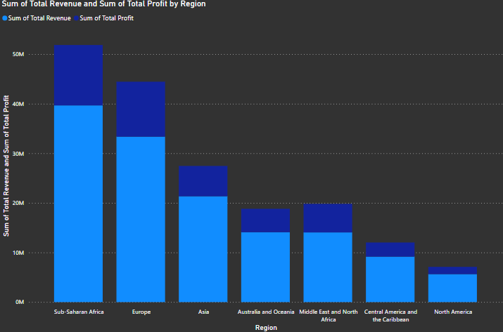

**Strategic Insights**

Given the high performance of cosmetics and office supplies, Amazon should continue to invest in and promote these categories. Enhancing marketing efforts and expanding product lines within these categories could further boost sales. The fruits category requires a strategic review to identify and address performance issues. If improvements are not feasible, discontinuing the category might be a better option to allocate resources more effectively.

The peak in sales in 2012 warrants a detailed analysis of the factors leading to this success, such as market conditions, promotional strategies, and consumer behavior. Developing strategies to replicate this success in future years could be beneficial. Furthermore, addressing the causes of the sales decline after 2012 and implementing corrective measures is crucial to stabilize and increase sales.

Strengthening operations and marketing efforts in Sub-Saharan Africa to capitalize on its high profitability should be a priority. Exploring opportunities to expand market presence and increase sales in this region can further enhance Amazon's performance. Meanwhile, the low profitability in North America necessitates a re-evaluation of business strategies. Implementing targeted initiatives to enhance market performance and profitability in this region is essential.

Investing in innovative technologies such as AI, machine learning, and automation can enhance customer experience and operational efficiency. Developing new features and services that cater to evolving consumer needs and preferences will help maintain Amazon's competitive edge. Strengthening customer engagement through personalized marketing, loyalty programs, and exceptional customer service is also vital. Utilizing data analytics to gain insights into customer behavior and preferences can enable more effective targeting and retention strategies.

**Recommendations**

A thorough analysis of the factors leading to the peak in 2012 should be conducted, including market conditions, promotional strategies, and consumer behavior trends during that period. This can provide valuable insights for future strategies. Focusing on enhancing high-demand categories like cosmetics and office supplies while revitalizing or discontinuing low-performing categories such as fruits can optimize resource allocation. Leveraging the high profitability of Sub-Saharan Africa by expanding market presence and enhancing sales efforts is recommended. Re-evaluating strategies in North America to address performance issues and improve profitability is also necessary. Finally, investing in innovative technologies and enhancing customer engagement through personalized marketing and exceptional service are key to sustaining growth.

**Conclusion**

This detailed analysis provides a comprehensive view of Amazon's sales performance from 2010 to 2017. By focusing on high-performing products and regions, addressing the decline in sales, and investing in customer-centric innovations, Amazon can optimize its business strategies and sustain its growth trajectory.